Geography bridging work
Complete tasks A and B and bring to your first Geography lesson in September.
- Read the extract from ‘Hazard by choice’(below)
- List all the factors which make Haiti vulnerable to hazards. What made this earthquake so bad?
2. To what extent does the extract support the idea that a vulnerable population are required for a natural hazard to become a disaster?

- Create an A4 summary page covering the processes at the 3 tectonic plate boundaries, including how volcanoes and earthquakes form.
https://www.bbc.co.uk/bitesize/guides/zt9y2p3/revision/3

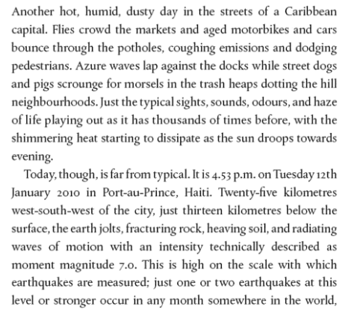

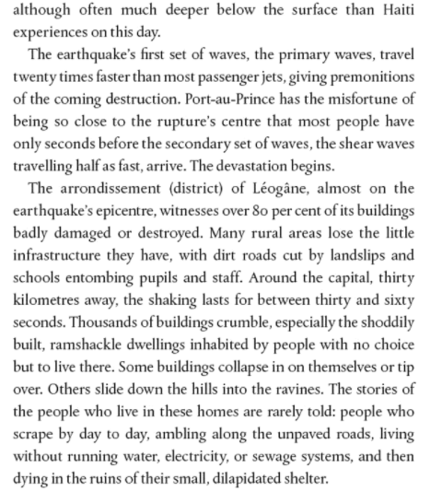
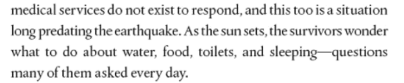
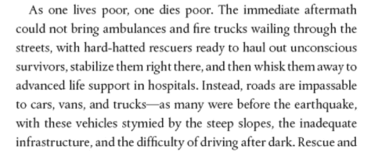
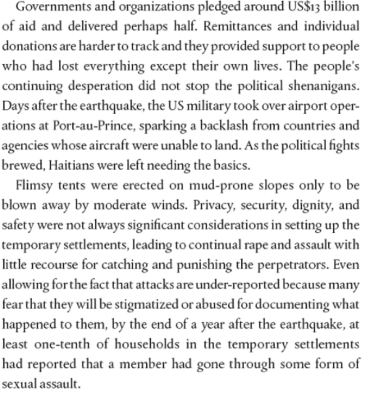
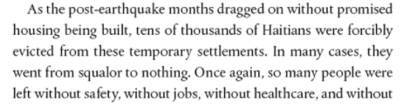
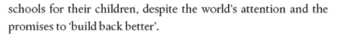
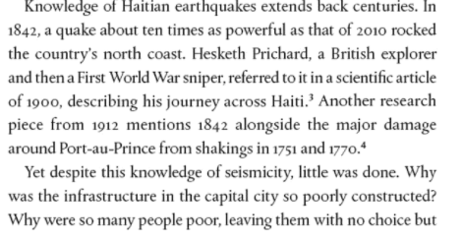
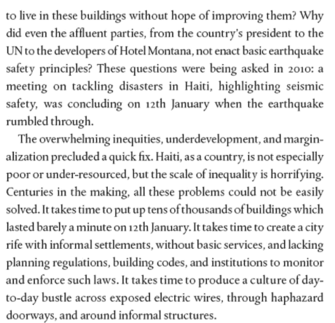

Wider reading/viewing
Prisoners of Geography (Marshall, T) – an insightful book which helps understand how physical geography impacts on political reality and really helps to understand how decisions of world leaders have been shaped by geography – a great introduction to geopolitics.
Factfulness: Ten reasons we’re wrong about the world – and why things are better than you think (Rosling, H 2019) – this is a must-read book from a geography perspective – this takes a more realistic view of the world, presenting issues in fact-based context. It is a rational look at how far the world has measurably improved and what’s left to be done.
Adventures in the Anthropocene (Vince, G) (2016) – this looks at the effects that humans are having on the surface and structure of the planet with a balanced view on recognising threats and dangers whilst also looking for practical answers and solutions.

Youthquake, why African demography should matter to the world , Paice, E. (2021)

Slowdown, Dorling,D. (2020)

The World’s Dirtiest River (Unreported world) https://www.channel4.com/programmes/unreported-world/on-demand/58399-001 10. Forests of Fear (Unreported World) - https://www.channel4.com/programmes/unreportedworld/on-demand/69224-006
11. Hurricane Hell (Unreported World) https://www.channel4.com/programmes/unreportedworld/on-demand/69224-007
12. The World’s Dirtiest Air (Unreported World) https://www.channel4.com/programmes/unreported-world/on-demand/67193-002

