Year 12 Bridging Work – Criminology
WJEC Level 3 Applied Diploma
Welcome to Criminology!

Criminology is the scientific study of crime and criminals. It includes looking at the causes of crime, how crime is measured and investigated, and how crime can be prevented in society. You have chosen a subject that combines elements of Psychology, Law, and Sociology.

Overview of the course
This is a two-year course made up of four units. Unit 1 and 2 will be completed in the first year which is assessed through an 8-hour Controlled Assessment and a formal examination. This is replicated in Year 2 with Units 3 and 4. You must complete and pass ALL units to gain the Diploma. The overall grades will be recorded on a scale A*-E.
Unit 1: Changing Awareness of Crime (Controlled Assessment)
Unit 2: Criminological Theories (Exam)
Unit 3: Crime Scene to Courtroom (Controlled Assessment)
Unit 4: Crime and Punishment (Exam)
Look at the specification for more detail about these topics. You can find this at: https://www.wjec.co.uk/umbraco/surface/blobstorage/download?nodeId=4752

Bridging Tasks
Each unit has an applied purpose which demands that learning is related to authentic case studies- this is the interesting bit! The following activities are designed to give you a flavour of criminology, give you a head start and the skills you need to be successful.
You need to complete tasks 1-6. The work should be completed on paper and in September will be added to your folder ready to use in lessons. We look forward to seeing the work you produce!
Task 1 – Criminal Theories: ‘Born Criminals’.
Instructions: read the following case study and answer the questions below on a separate piece of paper ready for putting in your folder for September.
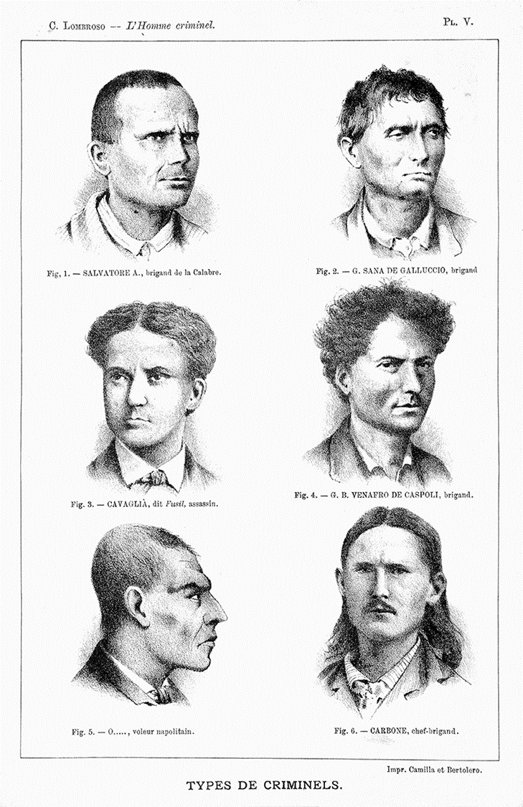
Case study: Cesare Lombroso (1835–1909), an Italian psychiatrist, used the term ‘atavism’ to describe the physical differences he believed he found between offenders and non-offenders (Fuller, 2013). Lombroso’s central theory was that the ‘criminal’ was an ‘atavistic throwback’ of a primitive stage of human evolution – meaning that those who committed crimes were a separate, socially inferior species, and a species that were abnormally, physically different to those who did not commit crime (Chamberlain, 2015). Cesare Lombroso called these abnormalities ‘atavistic characteristics’. Connected to the idea of atavistic characteristics is the idea of degeneration. According to Lombroso, offenders have certain physical characteristics of primitive humans, and they commit crime because of these biological abnormalities. Lombroso examined the facial and cranial features of approximately 4,000 living criminals and 383 deceased criminals as a scientific research experiment to examine the predictors of criminal behaviour. He found that 43% of the sample of living criminals presented five or more atavistic characteristics. This led Lombroso to conclude that involvement in crime was a product of biology and thus, criminals were born, not made.
Questions:
- Does this support that criminal behaviour is caused by nature or nurture?
- What is the main concept behind Lombroso's theory of criminal behaviour?
- Can you identify any problems with the way Lombroso conducted his research? Explain why?
- What might alternative theories suggest about what defines or leads to criminal behaviour.

Task 2 – Types of Crime: White collar crime
Instructions: Using the link below, and your own research, answer the questions 1 to 11.
https://www.youtube.com/watch?v=al5SLsoe0C0
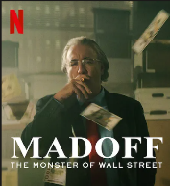
White collar crimes are crimes that are committed by people who are in a position of power or authority. White collar crime is non-violent and refers to financial crimes such as fraud, bribery, embezzlement, money laundering and protection rackets.
Case Study - Bernie Madoff ran the biggest Ponzi scheme in history. Ponzi schemes take money from investors and rather than investing to make a gain, they use the latest investment to pay dividends to existing investors. They require a constant source of money to be able to keep all the investors happy. The video explains how the scheme operated.
1. Why would people want to invest with Bernie Madoff?
2. What did the reports received by investors show about their investment?
3. What was really happening?
4. How did Madoff pay people their dividends and requests for money?
5. How did Madoff get away with his actions?
6. How did Madoff choose the rates of return that he offered to his clients?
7. Why weren’t Madoff’s activities reported to the authorities?
8. Why did Madoff’s scheme initially hit a problem?
9. Who turned Madoff in to the authorities?
10. Who were the victims of the scheme?
11. What does the case of Bernie Madoff show us about the nature of white-collar crime? Write a sentence on each of the following:
- complexity of white-collar crime
- the level of harm caused by white-collar crime
- the social status of the white-collar crime offenders
- the chances of catching and prosecuting white-collar crime offenders

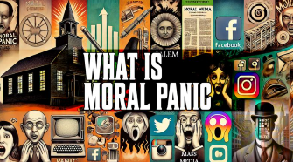
Task 3 – Impact of Media Representation of Crime: Moral Panic
Instructions: Using the clip below and your own research answer questions 1 to 10.
Moral Panic: A moral panic is a widespread, exaggerated social fear that a person, group, or behaviour threatens societal values, often amplified by media and authority figures. https://www.youtube.com/watch?v=r61ks18Bd7I
1. Who were the mods and rockers?
2. How does the Chief Constable describe the events of the Easter weekend in 1964?
3. According to the mod (in the hat), what was the cause of the trouble?
4. Why do you think the media reports used the word ‘battle’?
4. What might be the impact of the police and the media being present the next time the mods and rockers met?
5. What roles did Stan Cohen play during his research?
6. According to Cohen, why was the media so crucial in this case study?
7. How did the media exaggerate the situation?
8. What was the public response to the media coverage?
9. What was the impact of the media coverage on the mods and rockers?
10. How did the media cause a ‘moral panic’?

Task 4 – Impact of Media Representation of Crime: Response & Punishment

Instructions: The clip below shows some BBC coverage of the 2011 riots. Watch the clip and carry out your own research to answer the questions 1-7 below.
https://www.youtube.com/watch?v=gUmZGzlhaXw
1. What events took place on 4 August 2011?
2. What do you learn from the BBC clip about a possible cause of the riots? Why do you think this might have caused the riots?
3. What other factors may have played a part?
4. How would you explain the spread of the riots to other areas of London and other cities?
5. How does the BBC portray (a) the rioters, (b) the victims of the riots, and (c) the police?
6. In what way did Prime Minister David Cameron act as a ‘moral entrepreneur’ during the riots? (You may find it helpful to find a definition of moral entrepreneurs.)
7. What effect do you think the Prime Minister’s intervention might have had on the way suspects were dealt with by the courts?

