

Welcome to your Physics course at Ifield Community College – by far the best subject there is. The step up from GCSE to A-level is a big one – and to make this transition as smooth as possible we would like you to complete the following work.

We are aiming to remind you of some of the important Physics concepts that you will expand upon, to remind you of the key Maths skills that you already have and can further develop during the course and to help you start thinking about how to make good quality notes during your time studying A-level and beyond.
If you need help with any of this then please email ITy@ifieldcc.co.uk or CPi@ifieldcc.co.uk BEFORE you arrive in September.

Making Notes to Aid Understanding

You will be asked to read a lot more than you are used to for GCSE Science. Some of what you read will be ‘background’ – providing you an idea of context. Some of it will be essential knowledge – specific things you MUST know for the exams. It’s essential you are able to tell the difference and use your notes to help you understand those KEY IDEAS. Try this exercise:

The statements below are taken from the A-level Physics Specification, this tells you what you MUST know for the exam.

1) Pick out the KEY WORDS or PHRASES from these statements and put them in the box below:

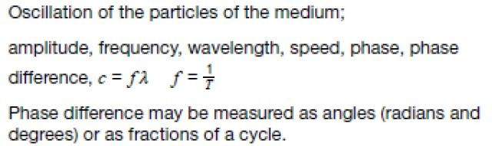

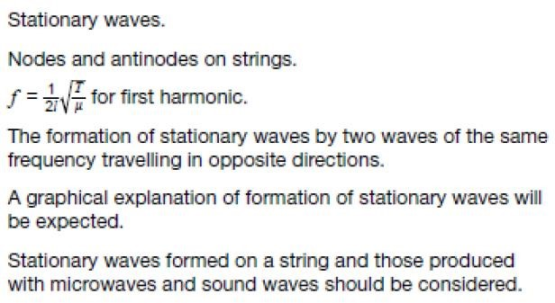

KEY WORDS/PHRASES to understand

Now use the website Sound Waves – Sound science for schools and colleges (salfordacoustics.co.uk)
and use this to pick out things that will help you with these statements.
From here make NOTES (i.e. keep it succinct) in the box below that aid with the understanding of the key knowledge from the specification – the purpose of these notes is:
  - To help you organize your thoughts and ensure you are clear about the content
  - To show me that you can pick out key points iii. To help you with revision when you need it later in the course Notes could/should include: iv. Definitions of key words or phrases
  - Clear labeled diagrams to illustrate points
  - Examples of applications of the key points vii. Worked examples of problems linked to the key points
Keep these notes to hand in with your work here – make sure you give them an appropriate title, it would also help to put the date on – this will help to keep you organised.

WHY PHYSICS?:
I would like you to write a paragraph for me explaining why you are choosing to do Physics at A-level. You might include:
- What topics you found particularly interesting at GCSE
- What topics you want to learn more about
- What your future plans are
- What excites you about learning Physics

Key maths skills

Physics is the study of the real world which can be a pretty complicated place. Physicists use maths in order to find solutions to real world problems. So, a sound understanding of some basic mathematical concepts will be essential to your success in this subject. Here are some key mathematical skills that you will need, you will have encountered all of these at GCSE level and so none of this should be new to you:

Graph drawing
You will need to decide on which quantities to plot, on which axes.
Scales need to be chosen to show correctly the quantities you are analysing
Lines of best fit (which may be curves) should be drawn correctly and you should know when to leave data out.

You will often be finding gradients to both straight lines and to curves.
You will also need to know how to estimate the area under a line.

Proportion
When you analyse a graph, you will need to decide how to describe the relationship between two variables. The words proportion and inverse proportion have specific meanings and you need to know when to apply them in a description.

Algebraic relationships
You need to understand how equations work, to be able to change the subject of a formula and to be able to correctly substitute numbers into a formula.

Exponents and standard form
If you know about this already then that is good. You need to have a feel for what answer is plausible and what is not. Expressing data in standard form will help you to manipulate numbers in such a way that you do not become overly reliant on the number which comes out of a calculator (which is only correct if you input the correct data). Get used to converting numbers like 1000 into an exponent (1x10⁴) for example.

Trigonometry
It is essential that you can use Pythagoras’ theorem (square of hypotenuse = sum of squares on opposite & adjacent), and basic trig functions: sin, cos and tan

On the next few pages, there are mathematical examples from two of the Physics units covered at GCSE they deal with forces & motion and electricity. Use your GCSE notes/revision materials from Maths and Science to help you to answer the problems.

Please note, if you are asked to plot a graph, you must use proper graph paper and a pencil and ruler. Ask for paper before you leave at the end of term.
When answering these problems, a full answer is expected. Do not simply write the final number and do not forget units.
Note, if you see for example ms⁻¹, this means the same as m/s which you would have encountered at GCSE.

Rearranging formulae (i.e. changing the subject)
Force = mass x acceleration
Rearrange to find mass

Momentum = velocity x mass
Rearrange to find mass

Speed = distance /time
Rearrange to find time

Acceleration = (final velocity – initial velocity)/time
Rearrange to find final velocity

Kinetic energy = ½ mass x velocity²
Rearrange to find velocity

Forces & Motion questions
- A car travels for 30s at a speed of 10ms⁻¹. Calculate the distance travelled by the car.

- The car accelerates from 10ms⁻¹ to 25ms⁻¹ in a time of 5s. Calculate the acceleration of the car.

- The following data was collected for a car travelling along a dual carriageway.

Time / s | Distance / m
0 | 0
2 | 1
4 | 2
6 | 4
8 | 7
10 | 12
12 | 18
14 | 22
16 | 26
18 | 27
20 | 28
22 | 28
24 | 28
26 | 28

- Plot a graph of this data with distance on the y-axis. You will plot a line (could be a curve) of best fit.
- Describe the motion of the car from zero to 26 seconds.
- Use the graph in to determine the times between which the car was travelling at a constant speed.
- By finding the gradient of the line in this time interval, calculate the speed of the car.

Current Electricity questions
The following may be useful:

voltage (V) V
current (A) = or I =
resistance (Ω) R

Which is the same as:

voltage (V) = current (A) x resistance (Ω) or V= I x R
The symbol for ohm is Ω.

- An electric kettle uses mains voltage (230 V). The current is 10 A. What is the resistance?

- A light bulb with resistance 60 Ω is connected to a 12 V battery. What is the current?

- A hairdryer uses mains voltage (230 V). It takes a current of 5A. Work out the resistance.

- A toy tractor has a 4.5 V battery operated motor. The resistance of the motor is 15 Ω. What is the current?

- A portable CD player takes a 6 V battery. The loudspeaker has a resistance of 4 Ω. What is the maximum current through the loudspeaker?

- A torch takes a 3 V battery. The light bulb for the torch has ‘0.2 A’ stamped on the side, so 3 V gives a current of 0.2 A.

- What is the resistance of the bulb?
- A battery with voltage 1.5 V is used. How much current will flow through the torch bulb?

The current and potential difference (pd) was measured in two different resistors.

Plot pd (V) on the y-axis and current (A) on the x-axis.

Note that this is not usual since current is the dependant variable. We do it like this to make the maths easier.

Find the change in current (∆ I) and the change in pd (∆ pd) then find the gradient in the normal way.

Gradient = ∆ pd / ∆ I (units are V/A)

Write down the values of these two resistors in Ω

pd (V) | I₁ (A) | I₂  (A)
2 | 0.1 | 0.3
4 | 0.2 | 0.6
6 | 0.3 | 0.9
8 | 0.4 | 1.2
10 | 0.5 | 1.5
12 | 0.6 | 1.8
14 | 0.7 | 2.1

Exponents and standard form.
Numbers in standard form are expressed as a decimal from 0 – 9. To do this it may be necessary to deal with the number of decimal places or zeros.

e.g.
4500 is expressed as 4.5x10³
0.0045 is expressed as 4.5 x10⁻³
Express the following numbers in standard form:

3670000

0.00073

318.67

0.45067

46 000 000 000 300

907037

0.0000003706

Trigonometry
Calculate the length of the hypotenuse

Calculate each of the non-right angles shown

7

6

5

θ

Write expressions for:
sin θ ₃
cos θ
tan θ ₄

F  1  F  2  45  N
  The resultant force of 45N is made up from two component forces F₁ and F₂.
  If the included angle is 30º, calculate the values of the component forces.

