Bridging the GCSE to A Level Gap
Subject: Design and Technology: Product Design
Exam board: AQA
In preparation for the start of the course in September, we would like you do complete an investigation into the Art Deco design movement.
Recommended reading
AQA AS/A-Level Design and Technology: Product Design (ISBN 978-1510414082)
AQA AS/A-Level Design and Technology: Product Design: Amazon.co.uk: Potts, Will, Morrison, Julia, Granger, Ian, Sumpner, Dave: 9781510414082: Books

Task 1
Watch the videos – Links Below.
Watch the YT Video about the Art Deco Movement and then answer the questions below.
https://www.youtube.com/watch?v=OK2L5UiDWCs&t=88s
Questions

- When was the Art Deco movement most prominent?

- What was happening in society at the time that influenced the formation of the Art Deco movement?

- What are the key features of Art Deco design?

- Find some examples of Art Deco architecture and products. Describe their style – what do all of the examples have in common?

- Discuss the work of two prominent Art Deco artists/designers. What were their most famous works? What impact did these designers have on other designers?

- Make a mood board consisting of 15 – 20 images which summarise the key features of the Art Deco design movement.

Task 2
Below is an image of the Braun RT Tube Radio designed by Dieter Rams. Redesign the radio so that is has a strong Art Deco influence whilst remaining true to its original features and purpose.
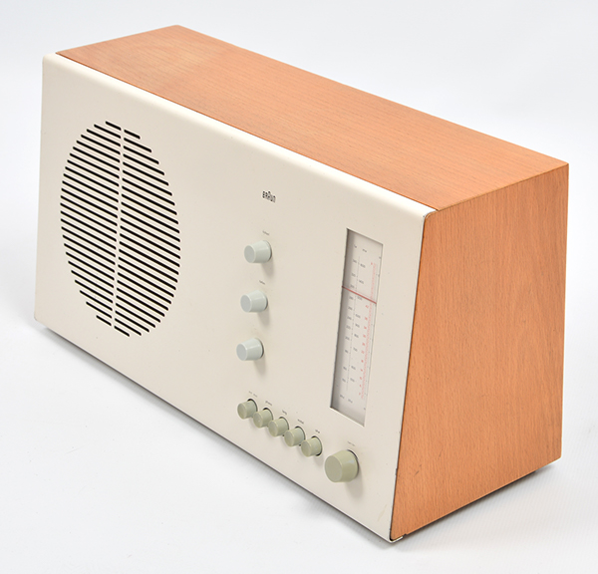

Please have your work saved to your OneDrive, or email to sla@ifieldcc.co.uk ready for your first Product Design lesson.

Useful links
https://www.youtube.com/watch?v=OK2L5UiDWCs&t=88s
Art Deco | Definition, Characteristics, History, Artists, Architecture, & Facts | Britannica
Art deco | Tate

